

Poverty and Neighbourhood Renewal
in West Cornwall:

A 2001 Census Update

Professor David Gordon and Dr Eldin Fahmy

University of Bristol

August 2004

Contents

Acknowledgements i

Summary 1

Introduction 2

2001 Census 4

Poverty 12

Child Poverty 15

Unemployment 19

Education 21

Health 24

Housing 26

Access to Services 30

Most Deprived Areas 32

References 36

Appendix: Priority Areas 2001 38

Acknowledgments

A large number of people have given up their valuable time to help the research team, without whose willing and enthusiastic cooperation, this research would not have been possible. Although it is invidious to single out individuals when we have been helped by so many, we would like to give special thanks to all the members of the Steering Group for their help, expertise and constructive criticism.

In particular, we wish to thank Matthew Brown, Kate Picknett and James Hardy for all their help, encouragement and support.

We would like to thank Clive Ratcliffe for supplying us with Council Tax band data for Penwith.

We would also like to thank Helen Anderson for her usual excellent help with editing this report.

We acknowledge Crown copyright of much of the data used in this report.

Summary

Poverty and Neighbourhood Renewal in West Cornwall: A 2001 Census Update

Professor David Gordon and Dr Eldin Fahmy

This research up-dates the statistical elements of the Poverty and Neighbourhood Renewal in West Cornwall research carried out by the University of Bristol and Cornwall Health Research Unit and published in January 2002. This previous work made extensive use of 1991 Census data to identify priority areas at 1991 Census Enumeration District level for Neighbourhood Renewal funding (West Cornwall LSP, 2002).

This current research uses the recently released 2001 Census data to identify priority areas for Neighbourhood Renewal funding based on the new Census small area geography of Output Areas. The main report focuses on:

- Identifying deprived areas - Identifying the most deprived Output Areas in West Cornwall (using comparable methods to the Poverty and Neighbourhood Renewal research).

- Identifying deprived areas by Neighbourhood Renewal theme - Identifying the most deprived Output Areas in West Cornwall for each of the Neighbourhood Renewal Fund (NRF) themes of Poverty/Low Income, Employment, Education, Health and Housing.

It is possible to construct a weighted scale of multiple deprivation which can be used to identify small areas with priority needs, based on 2001 Census and other available data. The following weighting was used:

- Poverty rate | 20%
- Child poverty rate | 20%
- Unemployment rate | 20%
- Standardised Ill Health Ratio | 12%
- No educational qualifications | 12%
- Housing Deprivation & Council Tax Band A | 8%
- Access to a car | 8%

Output Areas were then ranked according to their score on this cumulative index and a cumulative population variable constructed. On this basis, it was possible to identify the most deprived OAs for any population threshold (in this case the 33% level). In 2002, West Cornwall Together decided that the poorest areas in West Cornwall - in which a third of the population lived - should be eligible for Neighbourhood Renewal funding.

Conclusion
A more accurate and precise analyses of priority need is now possible than was achievable using 1991 Census data. In particular, smaller pockets of deprivation in the more rural areas of West Cornwall are now identifiable as having a priority level of need. The conclusion of this research is that the West Cornwall Local Strategic Partnership may wish to consider extending the priority areas eligible for NRF funding to include Carharrack, Lanner, Ponsanooth, Stithians, Four Lanes, Mabe Burnthouse, Mawnan Smith, Ludgvan and Germoe as all these areas can now be shown to have a priority level of need based upon ‘objective’ scientific criteria (see map over page).
Introduction

The purpose of this research is to up-date the statistical elements of the Poverty and Neighbourhood Renewal in West Cornwall research carried out by the University of Bristol and Cornwall Health Research Unit and published in January 2002. This previous work made extensive use of 1991 Census data to identify priority areas at 1991 Census Enumeration District level for Neighbourhood Renewal funding (West Cornwall LSP, 2002).

This current report uses the recently released 2001 Census data to identify priority areas for Neighbourhood Renewal funding based on the new Census small area geography of Output Areas. This report briefly describes the work undertaken and the result obtained and assesses the changes in deprivation of small areas of West Cornwall between 1991 and 2001. The report focuses on:

- Identifying deprived areas - Identifying the most deprived Output Areas in West Cornwall (using comparable methods to the Poverty and Neighbourhood Renewal research).

- Identifying deprived areas by Neighbourhood Renewal theme - Identifying the most deprived Output Areas in West Cornwall for each of the Neighbourhood Renewal Fund (NRF) themes of Poverty/Low Income, Employment, Education, Health and Housing.

Background
Rural areas differ considerably as a result of their unique development trajectories and this shapes the nature of their communities’ deprivation. Cornwall has a long history of disadvantage arising from its geographical peripherality and, specifically, the decline of traditional industries (mining, fishing, agriculture, textiles). In Cornwall as a whole, the 2000 Index of Local Deprivation (ILD) shows that, in 80% of Cornish wards, one fifth of the population is ‘multiply deprived’ and, in more than one fifth of wards, over a third of the population experiences significant multiple deprivation. Within Cornwall, the 2000 ILD reveals a further spatial concentration of deprivation primarily in the West Cornish districts of Kerrier and Penwith and especially in relation to income, employment, housing and health deprivation and child poverty. The recently released (28 April 2004) 2004 Index of Multiple Deprivation (2004 IMD) shows a similar pattern of deprivation in West Cornwall although, at time of writing, the results have not been finalised due to statistical errors. Census-based deprivation indices also estimate that nearly one fifth (18%) of households in West Cornwall were living in poverty in 1991 (Cemlyn et al, 2002; see also Payne et al, 1996 and Bruce et al, 1995a, 1995b).

Neighbourhood Renewal
In 1997, the Social Exclusion Unit (SEU) was established with a responsibility for developing integrated and sustainable solutions to the problems faced by Britain’s most deprived communities. In September 1998, as part of this strategy, the SEU recommended the introduction of a national strategy for Neighbourhood Renewal.

Drawing upon extensive research and consultation, the Government set out the main elements of its National Strategy Action Plan for Neighbourhood Renewal (NSAP) in January 2001. For the 88 most deprived Local Authority districts identified by central Government, including Kerrier and Penwith, a £900 million Neighbourhood Renewal Fund was founded to kick-start implementation of this National Strategy.

The NSAP outlines the Government’s strategy for achieving its overall objective that “within 10 to 20 years no-one should be seriously disadvantaged by where they live”. This ambitious objective is reflected in two long-term goals:

- To have lower worklessness; less crime; better health; better skills and better housing and physical environment in all the poorest neighbourhoods

- To narrow the gap on these measures between the most deprived neighbourhoods and the rest of the country

More detailed national targets have subsequently been established relating to the five core themes of Neighbourhood Renewal: employment; education; crime; health and housing and the physical environment.

West Cornwall Local Neighbourhood Renewal Strategy
In 2001/02, West Cornwall LSP, now known as West Cornwall Together, commissioned research from the University of Bristol and Cornwall College on Poverty and Neighbourhood Renewal in West Cornwall (see Cemlyn et al, 2002; 2004). This research enabled the identification of:

- Priority neighbourhoods
- Problems of deprived neighbourhoods

A key task of this research was to identify the poorest neighbourhoods in West Cornwall at small area level (ie sub-ward level). The DETR’s 2000 IMD (used to identify the 88 priority areas for NRF funding) is less appropriate in the West Cornish context since electoral wards cover relatively large spatial areas with diverse populations. Targeting NRF funding on this basis would result in significant pockets of poverty being overlooked, as well as the targeting of other areas which are not obviously ‘deprived’. Similarly, the ODPM’s 2004 IMD produces results for Super Output Area (Lower Level) which have a minimum population of 1,000 and an average population of 1,500 people. They are constructed by grouping together a number of Output Areas (typically five) and thus may be too large to identify pockets of poverty in villages in West Cornwall.

In 2000, the 1991 Census provided the only reliable data at the sub-ward level for the whole of the UK. Seven indicators derived from the 1991 Census were finally selected for analysis at the Enumeration District level (approximately 200-400 individuals). These measures approximate to the six ‘domains’ of deprivation (plus the supplementary child poverty index) identified by the DETR and included within the 2000 IMD:

- Poverty rate (Income)
- Child poverty rate (Supplementary)
- Unemployment rate (Employment)
- Percent of people aged 18 and over with no post school qualifications (Education)
- Standardised Illness Ratio (Health)
- Percent of households with no central heating (Housing)
- Percent of households with no car (Access to services)

On the basis of these measures, it was possible to construct a scale of multiple deprivation using an approach analogous to that used in the development of the 2000 IMD, ensuring that the final deprivation index was constructed in a similar way to that used to identify priority districts eligible for NRF funding. Enumeration Districts (EDs) were then ranked according to their score on this cumulative index. It was possible to identify the most deprived EDs for any population threshold (in this case, the 33% level, as decided by the Research Steering Group).

After extensive consultation, West Cornwall Together used this method to select the priority areas for NRF funding and these were included in the published Neighbourhood Renewal Strategy Document in March 2002 (see Figure 1).

Figure 1: Priority Areas at 33% Population Threshold, 1991 Census

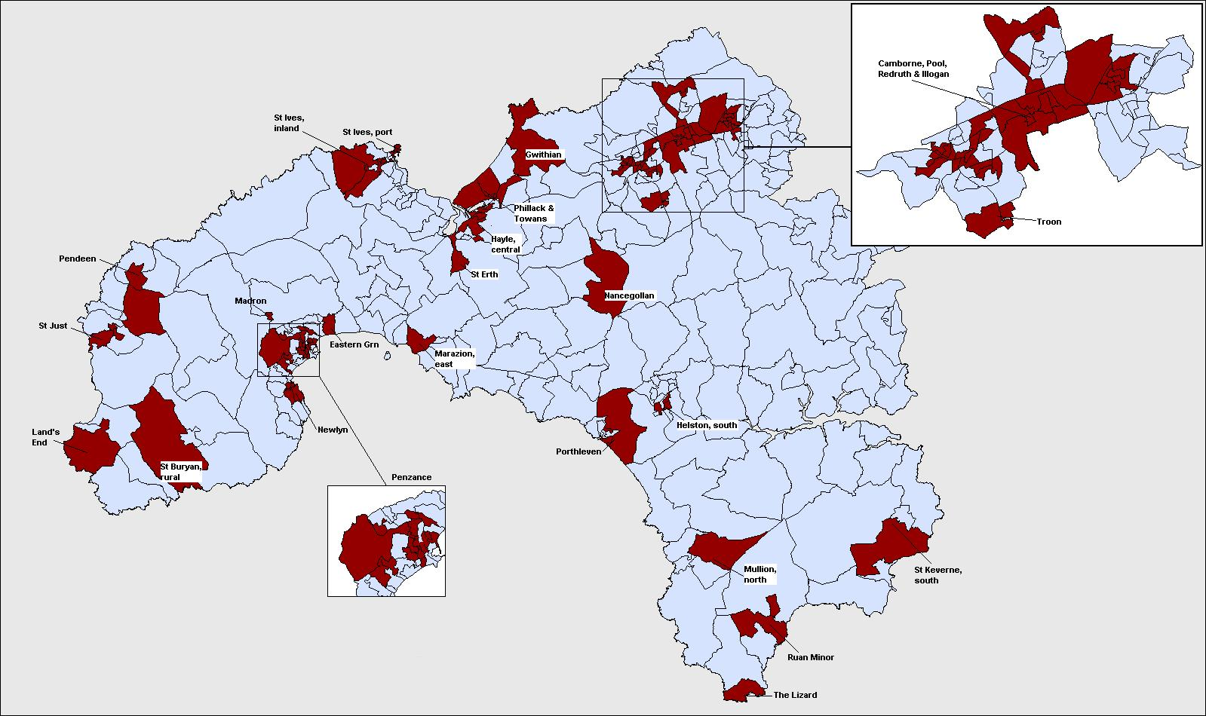

2001 Census

During 2003 and 2004, the 2001 Census data became available (in addition to a number of new and updated neighbourhood statistics). These statistical data had not been available in 2001 when the original research was undertaken. This report will aim to update the priority area analysis using the latest available data, in order to:

- Ensure that targets within Delivering Together (the West Cornwall Together Strategy) are relevant to existing need
- Ensure funding is targeted more effectively
- Undertake comparison with previously identified areas.

Questions
On Sunday, 29 April 2001, the national decennial Population and Housing Census was implemented by a field force of approximately 70,000 people in England and Wales. During 2003 and 2004, the small area data from the 2001 Census have become publicly available, although it is likely that some revisions to these data and further data releases will continue throughout 2004. The analyses reported here are correct as of the data release of 23 June 2004.

The 2001 Census contained a range of technical and substantive innovations and improvements compared with the 1991 Census. A number of additional questions were included which were designed to achieve a better-informed social policy aimed at minimising deprivation and social exclusion (ONS, 2000a):

- General health - as an aid to predicting future health needs
- Unpaid personal carers - enabling an assessment of demand on social services
- Lowest floor level - providing a measure of potentially unsuitable accommodation

In total, there were 43 separate items of information collected in Cornwall by the 2001 Census (ONS, 2000b), the details of which are listed below. (Topics marked in bold were not included in the 1991 Census).

- List of all usual residents at the address
- List of visitors and their addresses
- Type of accommodation
- Whether accommodation is self-contained
- Number of rooms
- Availability of bath, shower and toilet
- Lowest floor level of accommodation
- Availability of central heating
- Number of cars and vans owned or available for use
- Ownership of accommodation
- Type of landlord (for households in rented accommodation)
- Household members and their relationships
- Name
- Sex
- Date of birth
- Marital status
- Whether school child or student
- Term-time address for school children/students
- Country of birth
- Ethnic group
- Religion
- General health
- Provision of unpaid personal care
- Long-term illness, health problem or disability
- Usual address one year ago
- Academic and vocational qualifications
- Professional qualifications
- Whether or not in work (economic activity in the week before the Census)
- Whether or not looking for work
- Whether or not available for work
- Whether or not waiting to start a job
- Whether retired, student, looking after the family or home,
permanently sick or with a disability
- Time since last employment (if relevant)
- Whether an employee or self-employed
- Size of workforce of employing organisation
- Job title
- Description of job
- Supervisor status
- Business of employer at place of work
- Name of employer
- Address of place of work
- Means of travel to work
- Hours usually worked

In addition to the six new questions, the 2001 Census also improved and updated a number of the questions from the 1991 Census. Of particular relevance to this research are the changes in the question wording and/or definitions of:

- Qualifications
- Unemployment
- Overcrowding
- Social Class

Qualifications - In the 1991 Census, respondents over the age of 18 were asked to write in details of their academic, professional and vocational qualifications, including the name of each qualification, the field of study and date it was attained (Moss, 1999). The qualification questions in the 2001 Census were modified to include information on school level qualifications and also changed to facilitate automatic coding using pre-coded tick boxes.

Unemployment – The questions and definition of unemployment in the 2001 Census were changed to increase their comparability with the definition used by the International Labour Organisation (ILO). A person is defined as unemployed if he or she is not in employment, is available to start work in the next two weeks and has either looked for work in the last four weeks or is waiting to start a new job. An additional question was included in the 2001 Census on ‘time since last employment’ which enables identification of those people who have ‘never worked’ or who are ‘long term unemployed’. A person is defined as being long-term unemployed in the 2001 Census if the year they last worked was 1999 or earlier.

Overcrowding - In the 1991 Census, overcrowding was measured as more than one person per room. However, this definition was of little diagnostic value in rural areas such as Cornwall for identifying deprivation. In the 2001 Census, more sophisticated definitions of under and over-crowding were used based on the bedroom standard. This relates to the number of rooms ‘required’ by the members of the household (based on the relationships between them and their ages). The room requirement is calculated as follows:

- a one person household is assumed to require three rooms (two common rooms and a bedroom)
- where there are two or more residents it is assumed that they require a minimum of two common rooms plus one bedroom for:
  - Each couple (as determined by the relationship question)
  - Each lone parent
  - Any other person aged 16 or over
  - Each pair aged 10 to 15 of the same sex
  - Each pair formed from a remaining person aged 10 to 15 with a child aged under 10 of the same sex
  - Each pair of children aged under 10 remaining
  - Each remaining person (either aged 10 to 15 or under 10).

Social Class - The 2001 Census included two new questions on size of workplace and supervisory status in order to allow the adult population to be classified using the new National Statistics Socio-Economic Classification (NS-SEC) which is a superior social class classification to the Registrar General’s method used in the 1991 Census. Those in the lowest social class groups frequently have a much higher risk of suffering from poverty and deprivation than those in higher social class groups.

Finally, the 2001 Census output includes a single univariate table (UV67) which attempts, for the first time since the 1891 Census, to explicitly measure deprivation (see Booth, 1893). The classification is not related to the DTLR Index of Multiple Deprivation nor the NISRA Measures of Deprivation for Northern Ireland. It is one of the Alternative Household Classifications resulting from an ESRC project completed in 2001 (Wathan, Holdsworth and Leeser, 2004).

Four dimensions of household deprivation are given:

Dimension | Household is deprived if
Employment | Any member of the household aged 16 to 74 who is not a full-time student is either unemployed or permanently sick
Education | England and Wales: No member of the household aged 19 to 64 inclusive (males) to 59 inclusive (females) has level 2 education (Defined as having at least 5 GCSEs (A-C) or equivalent).  AND/OR  Any household member aged 16 to18 is not in full-time education and does not have level 2 education (Defined as at least 5 GCSEs (A-C) or equivalent).  Northern Ireland: No member of the household aged 19 to 64 inclusive (males) to 59 inclusive (females) has level 2 education (Defined as having at least 5 GCSEs (A-C) or equivalent).  AND/OR  Any household member aged 16 to 18 is not in full-time education and does not have level 2 education (Defined as at least 5 GCSEs (A-C) or equivalent).  Scotland: No member of the household aged 19 to 64 inclusive (males) to 59 inclusive (females) has group 1 education (Defined as having at least one O grade, standard grade, intermediate 1, intermediate 2, GCSE, CSE, Senior Certificate or equivalent).  AND/OR  Any household member aged 16 to18 is not in full-time education and does not have group 1 education (Defined as at least one O grade, standard grade, intermediate 1, intermediate 2, GCSE, CSE, Senior Certificate or equivalent).
Health and disability | Any member of the household has poor health in the last year, or has a long term limiting illness
Housing | Household accommodation is overcrowded AND/OR is not self-contained AND/OR does not have sole use of bath/shower and toilet AND/OR has no central heating. Overcrowding is defined as an occupancy indicator of –1 or less.

Geography
Arguably the most significant innovation in the 2001 Census is that the output geography used for the production of Census tables is different from the data collection areas. All previous Censuses since 1841 used EDs to both collect Census data and also as a basis for producing Census tables, ie the geography of data collection and table output were the same.

Unfortunately, EDs have limited social meaning as they are designed primarily to equalise as far as possible the workloads of enumerators (Clark and Thomas, 1990). In ‘difficult’ to collect areas they are often smaller or contain fewer people/households than in ‘easier’ to collect areas. In the 2001 Census, the Output Areas (OAs) for which detailed tables are published differ from the EDs. The OAs were constructed by amalgamating the 1.7 million unit postcodes into larger areas containing a minimum 40 households and 100 residents for Census Area Statistics and a minimum of 400 households and 1,000 people for Standard Tables.

These OAs were constructed using the Census data by an automated zone design methodology based on the automated zoning procedure (AZP) originally developed by Openshaw (1977). AZP operates by the iterative recombination of a series of building block zones into OAs, in such a way as to maximize the value of some objective functions and thus produce socially homogeneous areas (Martin et al, 2001; Martin, 2002). The homogeneity measure used in the 2001 Census consisted of four tenure categories and seven dwelling types:

Tenure
- Owner-occupied
- Rented privately
- LA/HA
- Other

Dwelling Type
- Detached
- Semi-detached
- Terraced
- Flat
- Part-house
- Commercial
- Non permanent

Thus, the OAs in the 2001 Census are amalgamations of 1.7 million unit postcode areas which contain similar dwellings and occupational tenures, e.g. semi-detached houses in owner occupation, local authority flats, etc. The OAs are the smallest areas for which detailed Census tables are available (although four Census statistics are available for all 1.7 million unit postcode areas).

The 2001 Census gives 553 OAs in West Cornwall which, on average, have a population of 281 people. These OAs range in population size from 102 people to 795, although the majority in West Cornwall have between 247 and 312 people. The OA with 795 people is an extreme outlier containing RNAS Culdrose. Figure 2 (overleaf) shows a dot plot of the population size of the 553 OAs of West Cornwall. With the exception of Culdrose OA, they are normally distributed.

Although the 2001 Census Output Area methodology represents a significant advance in measuring small area deprivation, it also makes comparisons between the 1991 and 2001 Census extremely difficult, since the 1991 EDs and the 2001 OAs have very different geographies.

Figure 2: Population of the 2001 Census Output Areas of West Cornwall

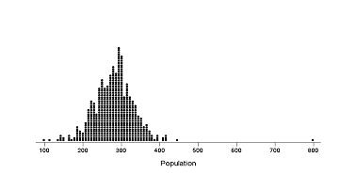

Mapping Deprivation at the Sub-ward Level
For each of the individual indicators described below, an interpolation procedure known as Inverse Distance Weighting (IDW) has been used to map the distribution of deprivation in West Cornwall. There are many advantages to taking spatial data beyond a purely descriptive display method, such as the thematic mapping of points using colours (ie a choropleth map). Deprivation is not constrained by Census boundaries, that is, deprivation usually does not dramatically fall from high levels on one side of an ED boundary to low levels on the other. IDW interpolation ‘smoothes’ the gradations in levels of deprivation across EDs to generate a more realistic model of deprivation. It also enables a spatial analysis of change over time in socio-economic data.

Interpolation is a mathematical process used to estimate values between known point observations. The IDW procedure converts point data into continuous grid layers ( a trend surface) by calculating a value for each grid node by examining surrounding data points lying within a defined search radius. The node value is calculated by averaging the weighted sum of all the points, the weight being a function of inverse distance. Thus, data points that lie progressively farther from the node influence the computed value far less than those lying closer to the node. A more detailed technical account of IDW interpolation is given in Cemlyn et al (2002).

(1)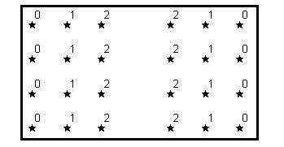(2)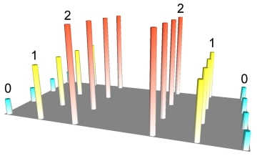(3)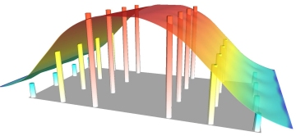
(1)

©Northwood Geoscience

In illustration (1) above, 24 points are arranged regularly with attribute values ranging from 0 to 2. Any numeric attribute can be represented in 3D form, as depicted in the second illustration. This image is actually a rendered grid generated using IDW interpolation by sampling only one data point and using a very small display radius equal to the width of a single column. However, grids are usually used to build a continuous surface that connects data points in space, effectively removing gaps in the representation of data. IDW achieves this by generating a moving average or ‘smoothing’ of the data, as shown in illustration (3).

This kind of trend surface methodology is made necessary because of Spatial Autocorrelation. Areas next to each other are likely to be more similar than areas further away. Spatial autocorrelation can be defined as the clustering pattern in the spatial distribution of a variable which is due to the very fact that the occurrences are physically close together, that is, that they are in geographical proximity. They are not independent of each other but are linked. The data are spatially dependent.

Spatial autocorrelation is widespread: rich people move to areas where other rich people live; disease can spread from one neighbour to another, etc. If the values in a poverty or health cluster are more alike than would be due to random processes, there exists a positive autocorrelation; if they are less alike than would occur through random processes, there exists a negative autocorrelation.

Figure 3 provides an example of an IDW thematic map of household deprivation in West Cornwall based on the percent of households suffering from two or more deprivations from 2001 Census Univariate Table 67 as described above.

Figure 3: Household Deprivation rate (%) in Kerrier and Penwith by 2001 Output Area (most deprived quartile)

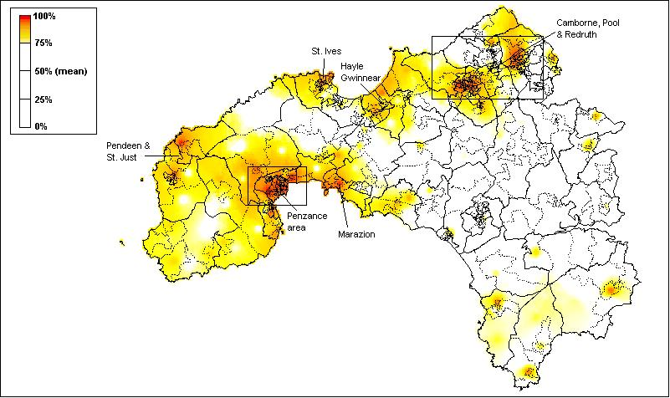

Poverty

Previous research suggests that high levels of poverty are endemic across much of West Cornwall (Payne et al, 1996; Cemlyn et al, 2002). Figure 4 shows the distribution of scores for each 1991 Census Enumeration District in West Cornwall for the poverty index. For each ED, the score represents the percentage of households living in poverty as defined by the Breadline Britain in the 1990s Survey (Gordon and Pantazis, 1997) and applied to the 1991 Census data (see Gordon, 1995). The areas highlighted in Figures 4 to 18 represent the upper quartile of scores for each of the deprivation indicators selected.

As Figure 4 shows, poverty in West Cornwall is concentrated in much of west Penwith (especially the coastal towns of Penzance and Newlyn, St. Ives, St. Just, and Hayle), as well as in the Camborne, Pool and Redruth area and the Lizard peninsula.

Figure 4: Poverty Rate (%) in Kerrier and Penwith by ED, 1991 (most deprived quartile)

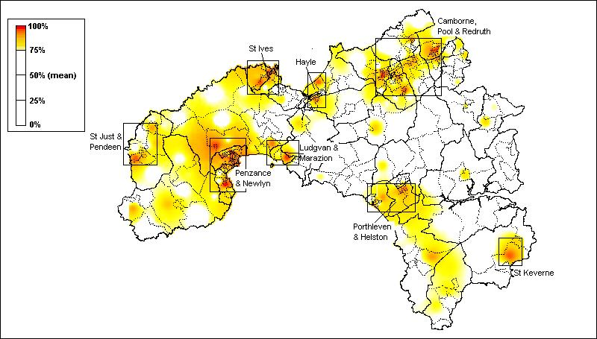
Source: 1991 Census of Population

Figure 5 shows the poverty rate for the 2001 Census Output Areas of West Cornwall. For each OA, the score represents the percentage of people living in poverty as defined by the Poverty and Social Exclusion Survey of Britain (PSE) (Gordon et al, 2000) and applied to the 2001 Census data. Methodological advances made by the PSE survey have allowed small area Census-based poverty estimates to be made at individual level for 2001 whereas in 1991 only household level estimates were possible.

Figure 5: Poverty Rate (%) by 2001 Output Area (most deprived quartile)

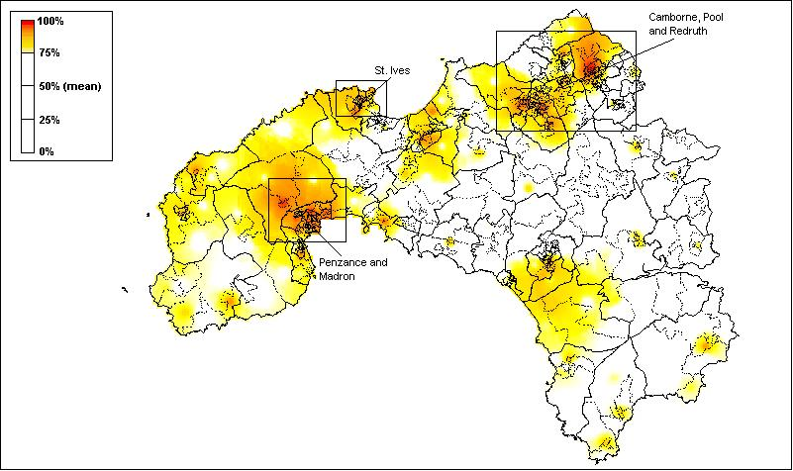

The Breadline Britain index estimates the numbers of households in an area that are likely to be poor, by weighting six groups recorded in the 1991 Census that have been shown to contain some households living in poverty (Gordon and Forrest 1995, Gordon 1995). It is calculated as follows:

Number of Poor Households =

21.7% of the number of households with no access to a car
+ 20.3% of the number of households not in owner-occupied accommodation
+ 16% of the number of lone parent households
+ 15.9% of the number of workers in Social Classes IV and V
+ 10.8% of the number of households containing a person with a limiting long-term illness (LLTI)
+ 9.4% of unemployed workers.

The PSE Index estimates the number of people in an area that are likely to be poor, by weighting eleven groups in the 2001 Census that have been shown to be at risk of suffering from poverty. It is calculated as follows (overleaf):

Number of poor people in 2001 =

64% of those overcrowded
+ 56% of those lacking amenities
+ 33% of those local authority renting
+ 28% of those in lone parent households
+ 22% of those with no car
+ 18% of those unemployed
+ 15% of those renting privately
+ 11% of those with no qualifications
+ 10% in poor health
+ 8% with long term illness
+ 8% in low social classes

Comparing Figures 4 and 5 shows that the geography of poverty did not change much between 1991 and 2001 in West Cornwall. In general, the poorest areas in 1991 remain the poorest areas in 2001. There are, however, a number of specific differences. In particular, there is much clearer identification in the 2001 map of a greater number of ‘rural’ pockets of poverty in Kerrier (eg the Lizard, Germoe, Four Lanes, Mawnan Smith, etc.) than were evident in the 1991 map. This is a result of the technical advances in both the 2001 Census and the PSE survey (discussed above) which have facilitated the identification of smaller pockets of poverty than was previously possible. These technical advances are important for the continued rural proofing of the West Cornwall Neighbourhood Renewal Strategy.

Table 1 (below) lists the worst (poorest) 20 OAs in West Cornwall. Column 1 shows the rank out of the total 553 OAs; Column 2 the estimated percent of poor people in the OA; Column 3 the OA 2001 Census code; Column 4 the electoral ward which contains the OA and Column 5, a brief description of the OA location. As expected, the poorest 20 OAs are concentrated in the Redruth, Camborne, Helston and Illogan areas as well as in Penzance and St Ives.

Table 1: Poverty Rate, Worst 20 Output Areas, 2001 Census

Rank | % Poor | Output Area | Ward Name | Output Area Location
1 | 66.4 | 15UDGP0019 | Redruth North | Murdoch Close
2 | 64.8 | 15UFFT0003 | Gulval and Heamoor | Rosehill
3 | 64.5 | 15UFGE0019 | Penzance East | Collinsey Road, Treweath Road
4 | 64.3 | 15UDGJ0014 | Illogan South | Illogan Highway - East Pool Park / Chywoon Gardens
5 | 64.1 | 15UFGD0009 | Penzance Central | St Clare Street
6 | 63.3 | 15UFGE0020 | Penzance East | Parc Mellan, Polweath
7 | 62.8 | 15UDGB0019 | Camborne South | Grenville Gardens
8 | 60.5 | 15UDGP0021 | Redruth North | Close Hill / Edmund Hill
9 | 58.8 | 15UDGC0013 | Camborne West | Wellington Close / Uglow Close
10 | 56.6 | 15UFGG0018 | Penzance South | Chywoone Crescent
11 | 56.5 | 15UFGK0007 | St Ives North | Trelawney Avenue
12 | 55.9 | 15UDGG0007 | Helston South | The Parade (West)
13 | 55.8 | 15UDGC0017 | Camborne West | Coronation Avenue
14 | 55.5 | 15UFGK0002 | St Ives North | Penbeagle, Industrial Estate
15 | 55.2 | 15UDGA0018 | Camborne North | Trenance Road / Hanover Court
16 | 54.6 | 15UDGB0006 | Camborne South | Pengegon Parc
17 | 53.7 | 15UDGP0020 | Redruth North | Treleigh Estate (Montague Avenue)
18 | 53.5 | 15UDGH0006 | Illogan North | Churchtown
19 | 53.3 | 15UFGD0011 | Penzance Central | Trezela Road, Trevean Road
20 | 52.8 | 15UDGC0015 | Camborne West | The Glebe - Pengwarras Rd / Manor Rd / Morrab Rd
Note: Poverty rate for Cornwall (21.8%) South West Region (20.7%) England (25.5%).
Child Poverty

The child poverty index measures the percentage of poor households with children. It is based on the poverty index derived from the Breadline Britain in the 1990s Survey and applied to the 1991 Census data (Gordon and Pantazis, 1997; Gordon and Loughran, 1997). This Breadline Britain child poverty index estimates the numbers of households with children that are likely to be poor in an area, by weighting five groups recorded in the 1991 Census that have been shown to contain some households living in poverty (Gordon and Loughran, 1997). It is calculated as follows:

Number of Poor Households with Children =

36.2% of the number of households with children with no access to a car
+ 30.6% of the number of household heads in Social Classes IV and V
+ 25% of the number of households not in owner-occupied accommodation
+ 15.7% of households with no workers.
+ 15.2% of the number of households containing a person with a limiting long-term illness (LLTI)

The PSE Index estimates the number of children in an area that are likely to be poor, by weighting seven groups of children in the 2001 Census that have been shown to be at risk of suffering from poverty (ie both materially deprived and suffering from low incomes – see discussion below). These are children who are:

- No Workers in employment in household (31.9%)
- Where the Household Reference Person has a low social class (20%)
- Social rented (LA or HA) accommodation (18.9%)
- No central heating (18.2%)
- Lone parent family (16.9%)
- Overcrowded compared with the occupancy standard (15.1%)
- No access to a car (10.3%)

These types of weighted small area poverty estimates are considered by many authors to be amongst the most accurate available (eg Lee et al, 1995; Burrows and Rhodes, 1998; Saunders, 1998; Glennerster et al, 1999).

The pattern of child poverty is slightly different to the overall poverty index described in Figure 4 (above). As Figure 6 shows, the distribution of child poverty in West Cornwall in 1991 was slightly more spatially concentrated than for poverty amongst the adult population, with significant clusters of child poverty in some of the more remote rural settlements such as the St Buryan area, and in St Keverne and the Lizard peninsula. However, the larger towns (Penzance and Newlyn, Camborne, Pool and Redruth, Hayle, and St Just) are also characterised by high rates of child poverty.

Figure 7 shows the estimated rates of child poverty in 2001 for dependent children rather than households with children as in 1991. As with the 2001 poverty rates estimates, shown in Figure 5, significant technical advances in the PSE (Gordon et al, 2000) have made this refinement possible.
Figure 6: Child Poverty Rate (%) in Kerrier and Penwith by ED, 1991 (most deprived quartile)

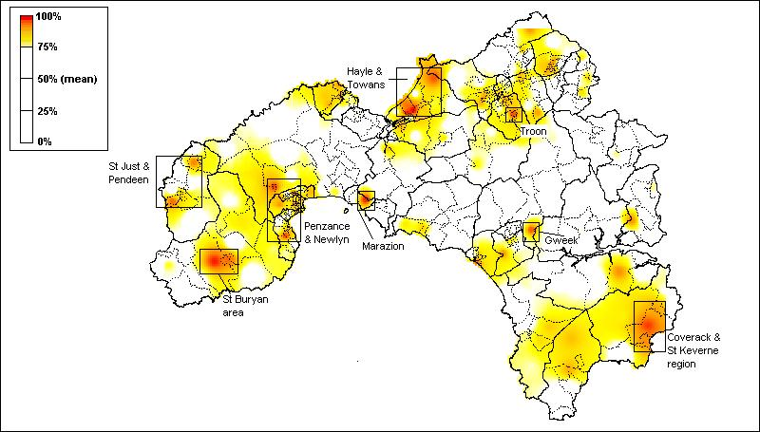
Source: 1991 Census of Population

Figure 7: Child Poverty Rate (%) in Kerrier and Penwith by 2001 Output Area (most deprived quartile)

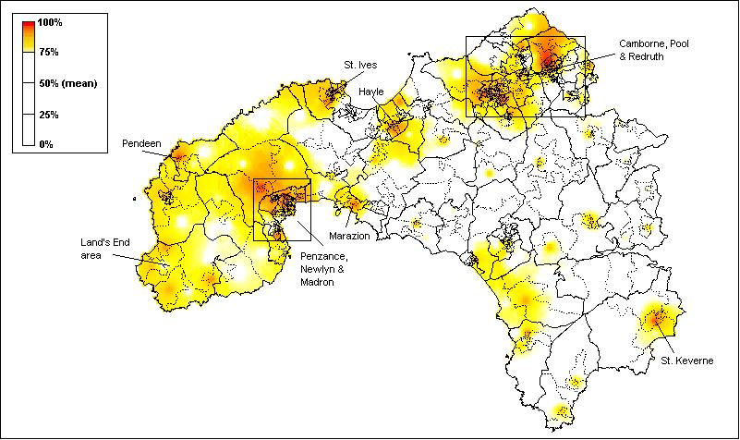

In December 2003, the Department for Work and Pensions (DWP) adopted three new ‘official’ definitions of child poverty as part of a tiered approach to measuring child poverty.

Absolute low income – to measure whether the very poorest families are seeing their incomes rise in real terms, we will monitor the number of children living in families with incomes below a particular threshold which is adjusted for inflation – set for a couple with one child at £210 a week in today’s terms.

Relative low income – to measure whether the poorest families are keeping pace with the growth of incomes in the economy as a whole, we will monitor the number of children living in households below 60% of contemporary median equivalised household income.

Material deprivation and low income combined – to provide a wider measure of people’s living standards, we will monitor the number of children living in households that are both materially deprived and have an income below 70% of contemporary median equivalised household income.

Using these definitions, poverty is falling when all three indicators are moving in the right direction (DWP, 2003).

The exact details of how these definitions will be operationalised by the DWP have not yet been finalised, however, the small area child poverty estimates for 2001 shown in Figure 6 are based as far as possible on the material deprivation and low income combined definition as the preliminary research for this indicator has been carried out using the PSE survey (McKay and Collard, 2004). This combined definition of child poverty as low income and deprivation is conceptually similar to the definition used previously in West Cornwall for the 1991 Census data (Figure 5). Many academic studies have argued that such a combined measure of child poverty is superior to indicators based upon just low income alone (see Townsend, 1979; Mack and Lansley, 1983; Gordon and Pantazis, 1997, Gordon and Townsend, 2002)

Comparing Figures 6 and 7 shows that the geography of child poverty in West Cornwall did not change greatly between 1991 and 2001. In general, again, the poorest areas in 1991 remain the poorest areas in 2001. There are, however, a number of specific differences. In particular, there is much clearer identification in the 2001 map of a greater number of ‘rural’ pockets of poverty in Kerrier and Penwith. The new 2001 child poverty estimates can be considered to be a sharper focused version of the 1991 estimates allowing the areas of greatest child poverty to be more precisely identified.

Table 2 (below) shows the 20 OAs with the highest rates of child poverty – the worst OAs are found in Penzance, Redruth, Illogan and Camborne as well as in parts of Morvah Pendeen and St Just and Gulval and Heamoor. The very high child poverty estimate of 82% of dependent children in the St Clare Street area of Penzance Central illustrates the considerable problems of some small areas in West Cornwall compared with Britain in general for which the national rate of child poverty based on this measure is 23%.

Table 2: Child Poverty Rate –Worst 20 Output Areas, 2001 Census

Rank | % Poor | Output Area | Ward Name | Output Area Location
1 | 82.1 | 15UFGD0009 | Penzance Central | St Clare Street
2 | 66.5 | 15UFGE0020 | Penzance East | Parc Mellan, Polweath
3 | 66.3 | 15UFGE0019 | Penzance East | Collinsey Road, Treweath Road
4 | 62.9 | 15UDGP0021 | Redruth North | Close Hill / Edmund Hill
5 | 61.1 | 15UDGJ0014 | Illogan South | Illogan Highway –  East Pool Park / Chywoon Gardens
6 | 61.0 | 15UFGG0018 | Penzance South | Chywoone Crescent
7 | 60.6 | 15UDGC0013 | Camborne West | Wellington Close / Uglow Close
8 | 60.4 | 15UDGP0023 | Redruth North | Pond Lane / Johns Park
9 | 59.4 | 15UDGP0019 | Redruth North | Murdoch Close
10 | 56.8 | 15UDGC0015 | Camborne West | The Glebe –  Pengwarras Rd / Manor Rd / Morrab Rd
11 | 56.4 | 15UFGE0011 | Penzance East | Ponsandane Brook, Ponsandane Bridge
12 | 56.3 | 15UFGD0008 | Penzance Central | Treneere Road, Parc Wartha Crescent
13 | 56.2 | 15UDGP0020 | Redruth North | Treleigh Estate (Montague Avenue)
14 | 55.8 | 15UFGG0015 | Penzance South | Gwavas Lane, Gwavas Estate, Treveneth Crescent
15 | 55.6 | 15UFGC0015 | Morvah Pendeen and St Just | Lower Boscaswell
16 | 55.0 | 15UDGB0009 | Camborne South | Pengegon - Foundry Road / Stray Park Way
17 | 54.7 | 15UFFT0003 | Gulval and Heamoor | Rosehill M.
18 | 54.3 | 15UDGG0007 | Helston South | The Parade (West)
19 | 53.9 | 15UDGB0006 | Camborne South | Pengegon Parc
20.5 | 52.9 | 15UFGD0002 | Penzance Central | Cardinnis Road
Note: Child Poverty rate for Cornwall (21.9%) South West Region (18.9%) England (23.2%).

Unemployment

Both the 1991 and 2001 Census indicators of unemployment are a more accurate measure of worklessness than Claimant Count estimates since the latter only includes economically active individuals in receipt of unemployment-related benefits. The 1991 Census data showed that the most substantial areas of worklessness are in north Penwith and north Kerrier as a whole, as well as in Penzance and the Lizard Peninsula, as Figure 8 (below) shows. Unemployment was a particular problem in the larger towns (St Ives, Hayle, Camborne, Pool and Redruth).

The analysis of the unemployment rate data from the 2001 Census (Figure 9 and Table 3 below) shows that significant problems still persist in parts of Penzance, Camborne, Hayle, St Just and St Ives. Comparing Figures 8 and 9 shows that the geography of unemployment did not change a great deal between 1991 and 2001 in West Cornwall. In general, the areas with greatest unemployment in 1991 remain the worst areas in 2001. There are however a number of specific differences, in particular, unemployment in some rural parts of Penwith (eg St Just and Pendeen areas, Lands End and St Buryan) appears to have become relatively worse over the 1990s whereas the employment situation parts of ‘rural’ Kerrier (eg Grade Ruan) has improved relative to other areas of West Cornwall. These results need to be treated with some caution due to the changes in the way that unemployment has been measured in the 1991 and 2001 Censuses (see discussion above).

Figure 8: Unemployment Rate (%) in Kerrier and Penwith by ED, 1991 (most deprived quartile)

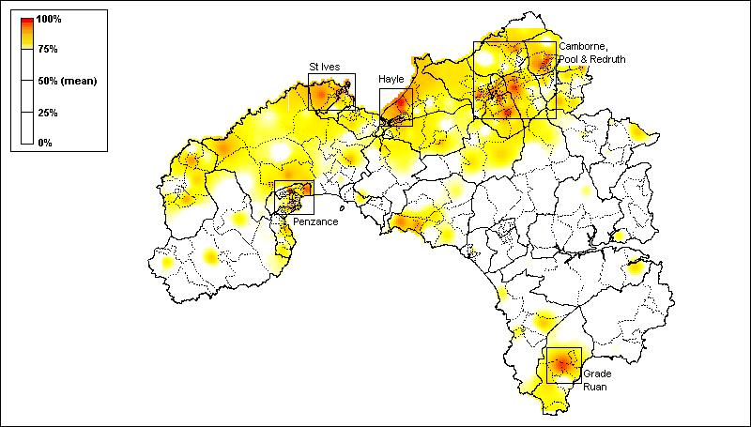
Source: 1991 Census of Population

Figure 9: Unemployment Rate (%) in Kerrier and Penwith by Output Area, 2001 (most deprived quartile)

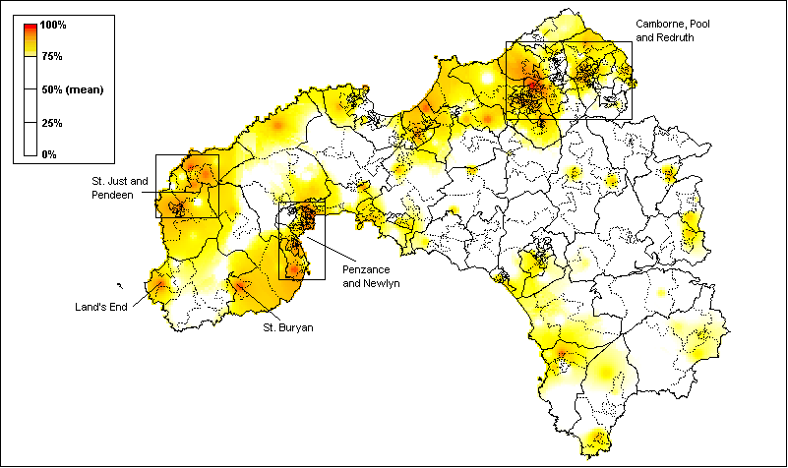
Source: 2001 Census of Population

Table 3: Unemployment Rate – Worst 20 Output Areas, 2001 Census

Rank | % Unemployed | Output Area | Ward Name | Output Area Location
1 | 24.7 | 15UDGA0004 | Camborne North | Tremarle Home Park
2 | 15.7 | 15UFGE0022 | Penzance East | Penare Terrace. Penare Road.
3 | 14.8 | 15UFFX0008 | Hayle South | Bodriggy Crescent
4 | 14.0 | 15UFGL0011 | St Ives South | Porthmeor Road
5 | 13.4 | 15UFGD0009 | Penzance Central | St Clare Street
6 | 12.8 | 15UDGQ0010 | Redruth South | Redruth Town Centre South  (Penryn St / Station Hill)
7 | 12.6 | 15UDGB0019 | Camborne South | Grenville Gardens
8 | 12.4 | 15UDGA0008 | Camborne North | Camborne Town Centre Central  (Trelawarren St - part)
9 | 12.3 | 15UDGQ0020 | Redruth South | Gweal-An-Top / Gew Terrace
10 | 12.2 | 15UFGG0001 | Penzance South | Belle Vue.
11 | 12.1 | 15UFGG0005 | Penzance South | Sheffield, Lower Sheffield, Trungle Parc,  Toddencoath, Trevithal, Halwyn
12 | 12.0 | 15UFGE0020 | Penzance East | Parc Mellan, Polweath
13.5 | 11.9 | 15UFGC0015 | Morvah Pendeen and St Just | Lower Boscaswell
13.5 | 11.9 | 15UDGR0017 | St Day Lanner and Carharrack | St Day - Vogue Hill / Trenant
15.5 | 11.8 | 15UFGF0013 | Penzance Promenade | Penlee Drive, Liby Meml
15.5 | 11.8 | 15UDGA0025 | Camborne North | Pool - East Hill
17.5 | 11.5 | 15UFFU0014 | Gwinear Gwithian and Hayle East | Loggans Moor
17.5 | 11.5 | 15UFGC0007 | Morvah Pendeen and St Just | Central St Just.
19.5 | 11.4 | 15UDGP0012 | Redruth North | Redruth Town Centre North
19.5 | 11.4 | 15UDGC0019 | Camborne West | Camborne Town Centre  (Union St / Tolcarne St)
Note: Unemployment rate for Cornwall (3.9%) South West Region (3.0%) England (3.9%).
Education

The distribution of educational disadvantage, as measured by the percentage of individuals without post-school qualifications in 1991 (degrees, professional and vocational qualifications), was very different to that of poverty, child poverty and unemployment (Gordon et al, 2002). The distribution of individuals with no post-school educational qualifications was much more dispersed, with significant clusters in many of the smaller and more remote rural settlements across Penwith and especially Kerrier, as Figure 10 (below) indicates.

The 2001 Census differed significantly from the 1991 Census in that it attempted to measure both school level and post school level qualifications. There are of course significant differences between those groups with post-school qualifications and those without such qualifications but this difference is not as great as the divide in life chances between those people with no qualifications at all and those with some qualifications. Thus, having no qualifications at all is a greatly improved measure of education deprivation compared to the ‘no post school qualifications’ measure available in 1991 Census. The significant differences in the geography of education deprivation shown in Figures 10 and 11 are largely a result of the different definitions used to measure education deprivation in 1991 and 2001, rather than a result of any underlying changes in relative education attainment between the areas of West Cornwall.

Figure 10 : Individuals with No Post-School Qualifications (%) in Kerrier and Penwith by ED, 1991 (most deprived quartile)

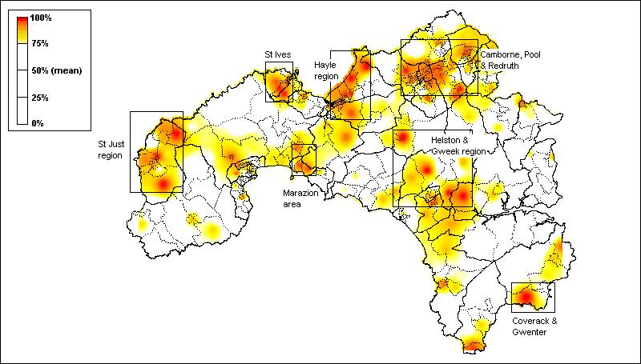
Source: 1991 Census of Population

Figure 11: Individuals with no qualifications in Kerrier and Penwith by 2001 Output Area (most deprived quartile)

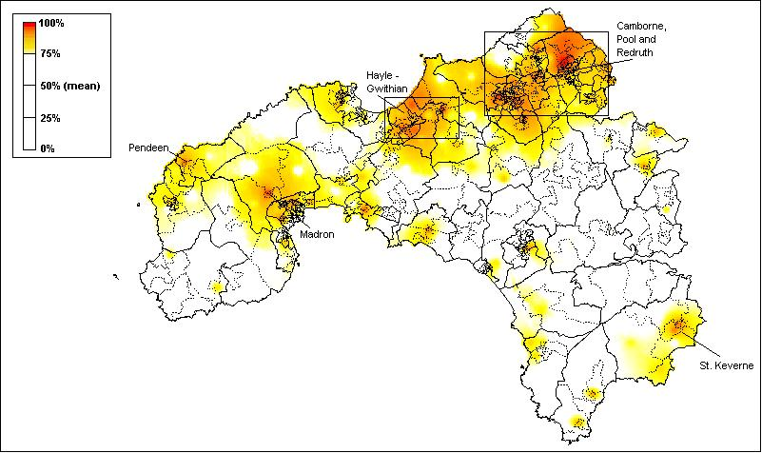
Source: 2001 Census of Population

The pattern in 1991 (Figure 10) partly reflected the different age profile of rural areas in comparison with the larger towns. Demographic change means that rural communities are increasingly characterised by greater concentrations of older residents compared with larger towns. Since educational attainment also reflects patterns of generational change, it is to be expected that educational attainment would be relatively low in many isolated rural communities with ageing populations. However, in 1991, many of the EDs in West Cornwall with the highest scores for educational under-achievement were also concentrated in the larger coastal towns of St Ives, St Just, and Hayle, as well as across the Camborne, Pool and Redruth area.

The better indicator of lack of education achievement in the 2001 Census (ie no school level or post-school qualifications) has a somewhat different distribution to the 1991 Census indicator of education deprivation (see Figure 11 and Table 4). The highest rates of educational under-achievement are found in Helston, Camboure, Redruth, Marazion and Perranuthnoe, Madron and Zennor, Hayle, Morvah Pendeen and St Just and Illogan. In the Penberthy Road area of Helston South, two thirds of population aged 16 to 74 had no educational qualifications at all in 2001 and, in a significant number of OAs in West Cornwall, the majority had no educational qualifications, indicating a need for continued life long learning resources.

Table 4: No Qualifications – West Cornwall Worst 20 Output Areas, 2001 Census

Rank | % No Qualifications | Output Area | Ward Name | Output Area Location
1 | 67.1 | 15UDGG0004 | Helston South | Penberthy Rd (East)
2 | 62.8 | 15UDGC0017 | Camborne West | Coronation Avenue
3 | 61.5 | 15UDGC0013 | Camborne West | Wellington Close / Uglow Close
4 | 60.5 | 15UDGP0020 | Redruth North | Treleigh Estate (Montague Avenue)
5 | 58.9 | 15UDGG0002 | Helston South | Trevenen Rd / Kingsley Way / Oates Rd
6 | 58.8 | 15UDGP0017 | Redruth North | Harmony Close / Tresaderns Rd
7 | 57.3 | 15UFGB0005 | Marazion and Perranuthnoe | St Levan Road
8 | 57.2 | 15UDGJ0019 | Illogan South | Wheal Agar / Treloweth Rd
9 | 55.0 | 15UDGP0019 | Redruth North | Murdoch Close
10 | 54.3 | 15UDGH0006 | Illogan North | Churchtown
11 | 53.7 | 15UDGA0002 | Camborne North | Enys Road
12 | 53.5 | 15UFGA0004 | Madron and Zennor | Madron (west)
13.5 | 53.1 | 15UDGC0015 | Camborne West | The Glebe –  Pengwarras Rd / Manor Rd / Morrab Rd
13.5 | 53.1 | 15UDGA0004 | Camborne North | Tremarle Home Park
15.5 | 52.2 | 15UFGC0009 | Morvah Pendeen and St Just | St Just (East)..
15.5 | 52.2 | 15UDGG0014 | Helston South | Trengrouse Way (East) / Vyvyan Place
17 | 51.9 | 15UFFX0008 | Hayle South | Bodriggy Crescent
18 | 51.8 | 15UDGP0021 | Redruth North | Close Hill / Edmund Hill
19.5 | 51.7 | 15UFFU0005 | Gwinear Gwithian and Hayle East | Connor Downs (Arundel way)
19.5 | 51.7 | 15UDGG0006 | Helston South | Trelawney Rd / Trengrouse Way (West)
Note: No Qualification rate for Cornwall (28.9%) South West Region (26.2%) England (28.9%).

Health

The Standardised Illness Ratio (SIR) measures the incidence of illness (morbidity) standardised by age and sex, where a score of 100 represents the average health of the population of England and Wales. Thus, a score of 167 across an ED means that residents are 67% more likely to experience a “long term illness, health problem or handicap which limits their daily activities or the work they can do” compared with the average for England and Wales. Conversely, a score of 50 means that residents are less likely to experience illness compared with the average for England and Wales.

As Figure 12 shows, ill health in West Cornwall in 1991 was concentrated mainly in north Kerrier. The 1991 EDs in West Cornwall with the highest scores (ie within the upper quartile of the distribution) were predominantly in the Camborne, Pool, Redruth area. Smaller pockets of ill health are also evident in the large coastal towns of Penzance and Newlyn, St Ives, and Hayle, as well as in the Pendeen area and the Lizard peninsula.

Figure 12: Standardised Illness Ratio in Kerrier and Penwith by ED, 1991 (most deprived quartile)

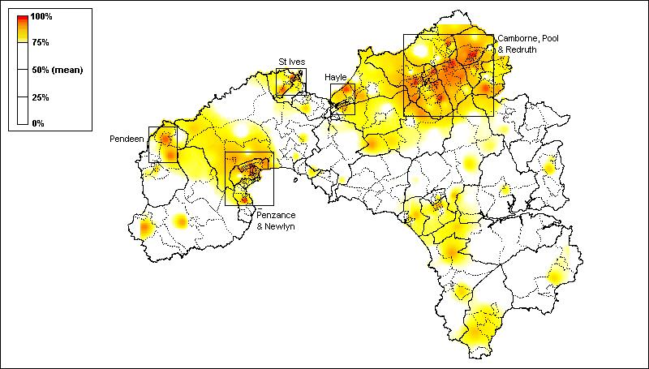
Source: 1991 Census of Population

As discussed above, the 2001 Census included not just the Limiting Long Term Illness and Disability question but also a measure of general health. Figure 13 shows the distribution of a standardised ill health indicator composed of those who answered that they had either a limiting long term illness OR who classified their health as ‘Not Good’ in answer to the General Health Question in the 2001 Census.

The distribution of limiting long term illness and not good health at Output Area level in 2001 (Figure 13) appears to be fairly similar to that of standardised limiting long term illness in 1991 (Figure 12). Table 5 shows that the Output Areas with the worst relative health were in Camborne, Penzance, Illogan, Gulval and Heamoor, Redruth, St Ives and Helston. In two OAs - Pengegon – Foundry Road / Stray Park Way in Camborne South and St Clare Street in Penzance Central - the standardised ill health ratio was twice the national average for England and Wales (ie there were twice as many ‘sick’ people as would be expected in these two areas given their age and gender).

Figure 13: Standardised Ill Health Ratio in Kerrier and Penwith by 2001 Output Area (most deprived quartile)

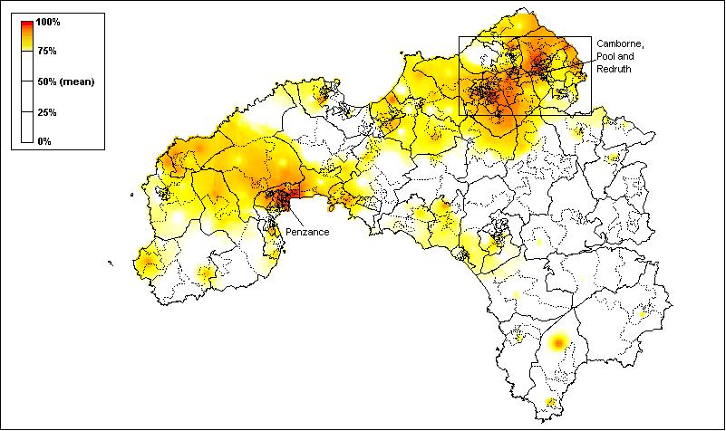
Source: 2001 Census of Population

Table 5: Standardised Ill Health Ratio – Worst 20 Output Areas, 2001 Census

Rank | SIR | Output Area | Ward Name | Output Area Location
1 | 230 | 15UDGB0009 | Camborne South | Pengegon – Foundry Road / Stray Park Way
2 | 207 | 15UFGD0009 | Penzance Central | St Clare Street
3 | 198 | 15UFGE0020 | Penzance East | Parc Mellan, Polweath
4 | 196 | 15UDGH0006 | Illogan North | Churchtown
5 | 195 | 15UFFT0003 | Gulval and Heamoor | Rosehill M.
6 | 191 | 15UDGP0012 | Redruth North | Redruth Town Centre North
7.5 | 188 | 15UFGD0011 | Penzance Central | Trezela Road, Trevean Road
7.5 | 188 | 15UFGE0017 | Penzance East | Jennings Street
9 | 187 | 15UDGJ0012 | Illogan South | Illogan Highway – Killiersfield
10 | 181 | 15UFGE0011 | Penzance East | Ponsandane Brook, Ponsandane Bridge
11.5 | 177 | 15UFGE0022 | Penzance East | Penare Terrace. Penare Road
11.5 | 177 | 15UDGP0010 | Redruth North | Green Lane / Blight's Row
13 | 176 | 15UFGK0002 | St. Ives North | Penbeagle, Industrial Estate
14 | 171 | 15UDGP0021 | Redruth North | Close Hill / Edmund Hill
15 | 169 | 15UDGB0010 | Camborne South | Pengegon - Gwelmor / Meneth Rd / Penforth
16 | 167 | 15UDGG0011 | Helston South | Albion Road
17.5 | 166 | 15UDGC0015 | Camborne West | The Glebe - Pengwarras Rd / Manor Rd / Morrab Rd
17.5 | 166 | 15UFGD0001 | Penzance Central | Penlee Park, North Parade
19 | 165 | 15UFGG0018 | Penzance South | Chywoone Crescent
20.5 | 164 | 15UDGJ0014 | Illogan South | Illogan Highway - East Pool Park / Chywoon Gardens
Note: Standardised Ill Health Ratio rate for Cornwall (101) South West Region (91) England (99).
Housing

In 1991, the distribution of households lacking central heating in West Cornwall differed significantly from the distribution of poverty, child poverty and unemployment. The EDs with the greatest proportion of households lacking this basic amenity were concentrated predominantly in west Penwith and especially in the Penzance and Newlyn area, as well as in St Ives and St Buryan.

Figure 14: Households with No Central Heating (%) in Kerrier and Penwith by 1991 ED (most deprived quartile)

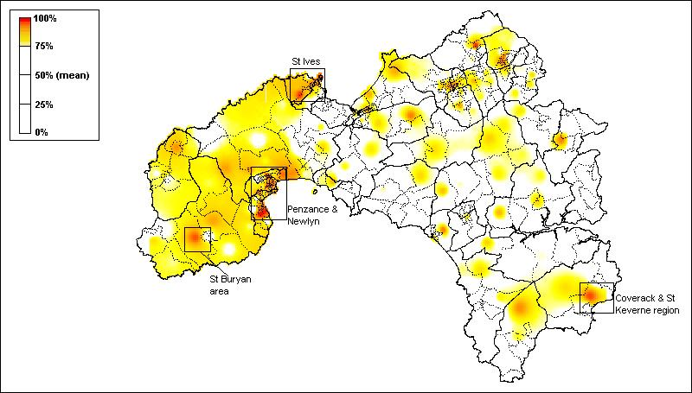
Source: 1991 Census of Population

The 2001 Census also included a more sophisticated measure of housing deprivation than just lack of central heating (see discussion above). Figure 15 shows the distribution of the most housing deprived 25% of output areas showing what proportion of people were living in houses that had no central heating OR were sharing accommodation OR were overcrowded using a measure that was conceptually similar to the bedroom standard. In the 2001 Census, the geography of housing deprivation shows high concentrations of ‘poor’ housing in parts of Penzance, St Bunyan, St Just, St Ives, Hayle and Ludgvan & Towednack. The housing problems in west Penwith appear to have persisted throughout the 1990s and into the 21st Century.

However, the measures of housing deprivation available in the 2001 and 1991 Censuses are somewhat limited and give little indication on the quality of the housing stock. The value of a dwelling is one possible indicator of both housing quality and desirability and an indication of dwelling value at small area level is available from the Council Tax data. Figure 16 shows the proportion of dwellings in Council Tax Band A (valued at under £40,000 on 1 April 1991).

Figure 15: Households with No Central Heating or Overcrowded or Sharing Accommodation (%) in Kerrier and Penwith by 2001 Output Area

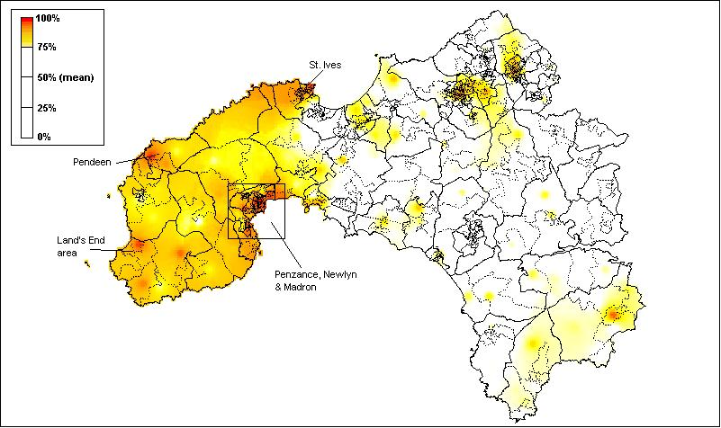
Source: 2001 Census of Population

Figure 16: Dwellings in Council Tax Band A (%) in Kerrier and Penwith by 2001 Output Area

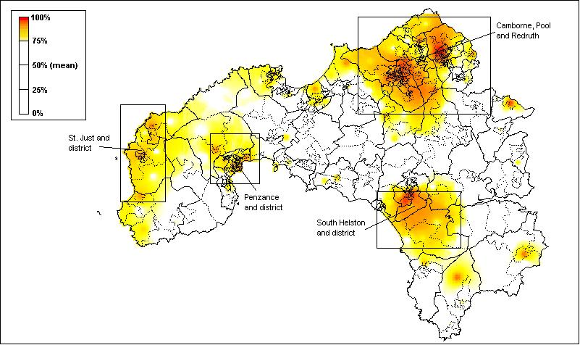
Source: 2001 Census of Population

It is clear from Figure 16 that low value dwellings are concentrated in the Illogan, Camborne and Redruth area and in Helston and district. Dwellings in St Ives have a higher value even if the people living in some of these houses are suffering from housing deprivation.

It is possible to combine both the indicators of housing deprivation (Figure 15) with the Council Tax Band A indicator (Figure 16) to produce a single final housing index for Neighbourhood Renewal purposes. Figure 17 shows the geography of this final housing index at Output Area level in 2001. In this index, the Council Tax band data and the housing deprivation data have been given an equal weight so it is unsurprising that Figure 16 looks like a combination of the maps shown in Figures 14 and 15. Table 6 shows the worst 20 Output Areas ranked on the basis of this final housing index and also the percent of people living in housing deprivation in 2001 and the percent of dwellings in Council Tax Band A.

Figure 17: Final Housing Index– Combined ranking of % Housing Deprivation and % Council Tax Band A in Kerrier and Penwith by 2001 Output Area

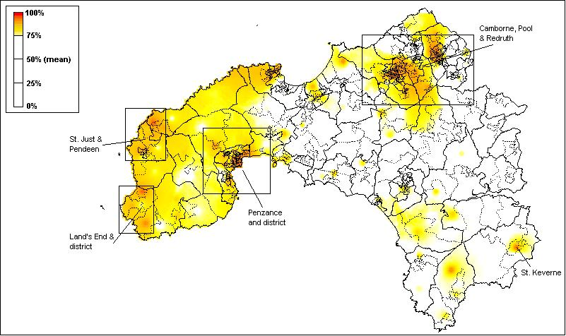
Source: 2001 Census of Population

Table 6: Final Housing Index– Combined ranking of % Housing Deprivation and % Council Tax Band A - Worst 20 Output Areas, 2001 Census

Ward | Output Area | Final Housing Index | Housing Deprivation | Council Tax Band A | Output Area Location
Penzance Central | 15UFGD0009 | 63.40 | 6.00 | 94.81 | St. Clare Street
Redruth North | 15UDGP0018 | 47.00 | 18.75 | 87.27 | Pengover Parc / Strawberry Close / Penhale Estate
Camborne North | 15UDGA0017 | 47.00 | 27.75 | 72.73 | Pendarves St / Edwards St
Illogan North | 15UDGH0006 | 39.00 | 28.50 | 100.00 | Churchtown
Morvah Pendeen and St. Just | 15UFGC0015 | 56.30 | 29.50 | 65.05 | Lower Boscaswell
Camborne North | 15UDGA0001 | 48.10 | 29.50 | 69.42 | North Roskear Road
Penzance East | 15UFGE0011 | 57.10 | 33.00 | 62.50 | Ponsandane Brook, Ponsandane Bridge
Redruth North | 15UDGP0009 | 39.00 | 35.75 | 88.49 | Bellevue / Miner's Court
Penzance East | 15UFGE0017 | 43.70 | 36.50 | 70.99 | Jennings Street
Redruth South | 15UDGQ0010 | 42.90 | 36.75 | 72.90 | Redruth Town Centre South (Penryn St / Station Hill)
St. Keverne | 15UDGS0002 | 45.20 | 37.00 | 66.21 | Treskewes Estate
Penzance Promenade | 15UFGF0005 | 45.50 | 41.00 | 63.03 | Rugby Football Ground, Alexandra Place, Mennaye Road
Camborne North | 15UDGA0008 | 41.90 | 44.00 | 66.42 | Camborne Town Centre Central (Trelawarren St - part)
Camborne West | 15UDGC0022 | 43.60 | 45.25 | 63.28 | Cross St / West Charles St / East Charles St / Stray Park Rd
Penzance East | 15UFGE0020 | 45.10 | 45.50 | 61.36 | Parc Mellan, Polweath
Camborne South | 15UDGB0019 | 34.50 | 46.00 | 100.00 | Grenville Gardens
Penzance Central | 15UFGD0011 | 35.50 | 47.50 | 86.72 | Trezela Road, Trevean Road
Redruth North | 15UDGP0016 | 39.50 | 48.50 | 68.50 | Penhale Estate
Penzance Central | 15UFGD0002 | 54.50 | 49.50 | 51.66 | Cardinnis Road
Note: Housing Deprivation rate for Cornwall (21.4%) South West Region (13.3%) England (15.2%).

Access to Services

Access to a car is a key dimension of access to community services in rural areas, especially since historical and new data reveal an overall trend of declining geographical availability for some essential services in many rural areas. Strikingly, the percentage of households in West Cornwall in 1991 without access to a car closely reflected the distribution of poverty amongst the adult population (Cemlyn et al, 2002).

Figure 18: Households with No Access to a Car (%) in Kerrier and Penwith by 1991 ED (most deprived quartile)

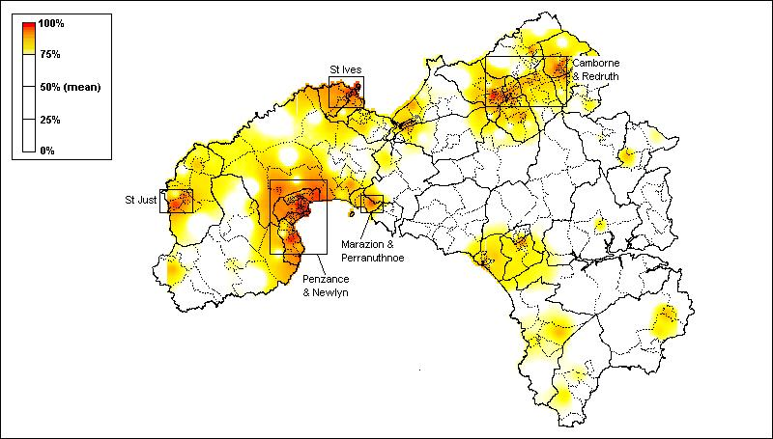
Source: 1991 Census of Population

Figure 18 shows levels of access to a car were lowest in 1991 in the larger towns (St Ives, St Just, Penzance and Newlyn, Hayle, and Camborne, Pool and Redruth). However, there were also substantial rural areas (eg west Penwith, the Lizard peninsula) where lack of access to a car was also a significant problem, especially given the remote rural location of these settlements.

The 2001 Census data also show that lack of access to a car remains concentrated in the larger towns – Penzance, St Ives, Redruth, Camborne, Hayle and Helston. However, the problems in some of the remoter rural areas also persisted throughout the 1990s. Table 7 shows that, in the St Clare Street area of Penzance Central, over 70% of people had no access to a car or van in 2001 and, in seven other OAs in parts of Penzance, Camborne and St Ives, over half the population were dependent on public transport.

Figure 19: Households with No Access to a Car (%) in Kerrier and Penwith by 2001 Output Areas

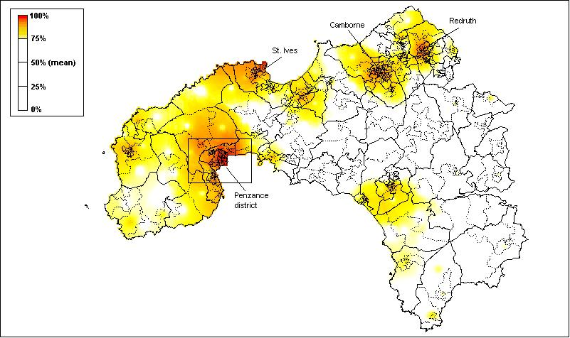

Table 7: No Access to a Car– West Cornwall Output Areas, 2001 Census

Rank | % No Car | Output Area | Ward Name | Area
1 | 70.6 | 15UFGD0009 | Penzance Central | St Clare Street
2 | 59.3 | 15UFGF0012 | Penzance Promenade | Chapel Street, Queen Street, Abbey Street
3.5 | 59.0 | 15UFGE0019 | Penzance East | Collinsey Road, Treweath Road
3.5 | 59.0 | 15UFGE0020 | Penzance East | Parc Mellan, Polweath
5 | 57.1 | 15UDGC0013 | Camborne West | Wellington Close / Uglow Close
6 | 55.9 | 15UFGE0017 | Penzance East | Jennings Street
7 | 53.1 | 15UFGL0014 | St Ives South | Barnoon, Portheor
8 | 51.1 | 15UFGL0011 | St Ives South | Ponsandane Brook, Ponsandane Bridge
9.5 | 46.2 | 15UDGP0021 | Redruth North | Close Hill / Edmund Hill
9.5 | 46.2 | 15UDGJ0014 | Illogan South | Illogan Highway –  East Pool Park / Chywoon Gardens
11 | 46.1 | 15UFGG0018 | Penzance South | Chywoone Crescent
12 | 45.5 | 15UFGD0002 | Penzance Central | Cardinnis Road
13 | 44.7 | 15UFGK0007 | St. Ives North | Trelawney Avenue
14 | 44.3 | 15UFGD0011 | Penzance Central | Trezela Road, Trevean Road
15 | 43.9 | 15UFGE0014 | Penzance East | Adelaide Street
16 | 43.6 | 15UDGP0009 | Redruth North | Bellevue / Miner's Court
17 | 43.3 | 15UFGC0009 | Morvah Pendeen and St Just | St Just (East)
18 | 42.6 | 15UDGG0007 | Helston South | The Parade (West)
19.5 | 41.0 | 15UFGE0011 | Penzance East | Ponsandane Brook, Ponsandane Bridge
19.5 | 41.0 | 15UFGD0008 | Penzance Central | Treneere Road, Parc Wartha Crescent
Note: The percent with no access to a car in Cornwall (13.6%) South West Region (13.5%) England (19.5%).

Most Deprived Areas

On the basis of the deprivation measures described above, it is possible to construct a scale of multiple deprivation. First, the scores for each 2001 Census Output Area were ranked for each measure. Secondly and, following the approach adopted by Cemlyn et al (2002) and the DETR in the construction of the 2000 Index of Multiple Deprivation at a ward level, the different ‘domains’ were weighted to broadly reflect the weightings used in the construction of that latter index. This ensured that the final multiple deprivation index was constructed in a comparable way to that used to identify priority areas eligible for Neighbourhood Renewal funding in 2002. The following weighting was used:

- Poverty rate | 20%
- Child poverty rate | 20%
- Unemployment rate | 20%
- Standardised Ill Health Ratio | 12%
- No educational qualifications | 12%
- Housing Deprivation & Council Tax Band A | 8%
- Access to a car | 8%

Output Areas were then ranked according to their score on this cumulative index and a cumulative population variable constructed. On this basis, it was possible to identify the most deprived OAs for any population threshold (in this case the 33% level). In 2002, West Cornwall Together decided that the poorest areas in West Cornwall - in which a third of the population lived - should be eligible for Neighbourhood Renewal funding.

Figure 20: Most Deprived Areas at the 33% Population Threshold, 2001 Census

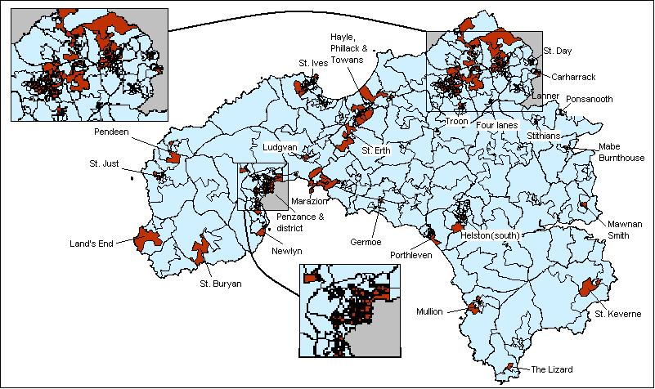

Figure 20 shows the priority areas for NRF funding as determined by this procedure. Figures 21 and 22 present the change in priority areas using two different methods. Finally, Figure 23 shows the most deprived areas from Figure 20 overlain on a digitised map of West Cornwall to ease identification.

Figure 21: Change in Priority Areas 1991 to 2001 at the 33% Population Threshold

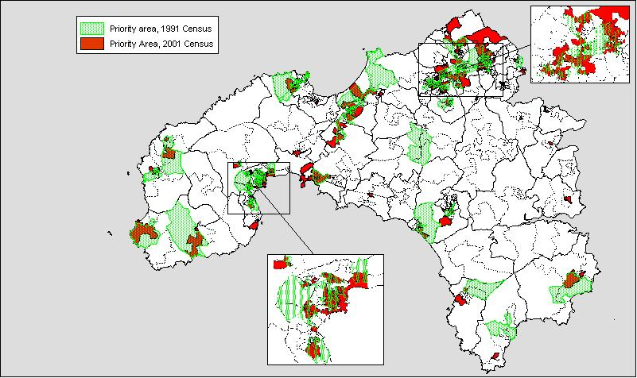

Figure 22: Relative Change in Priority Area Final Index between 1991 and 2001

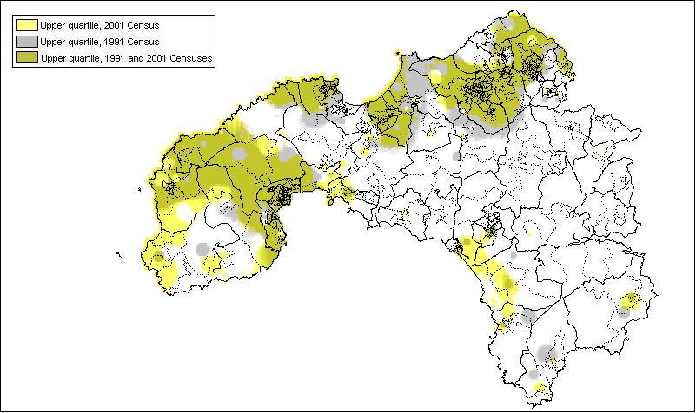

Figure 23: Priority Areas at the 33% Population Threshold, 2001 Census, overlain onto a map of West Cornwall

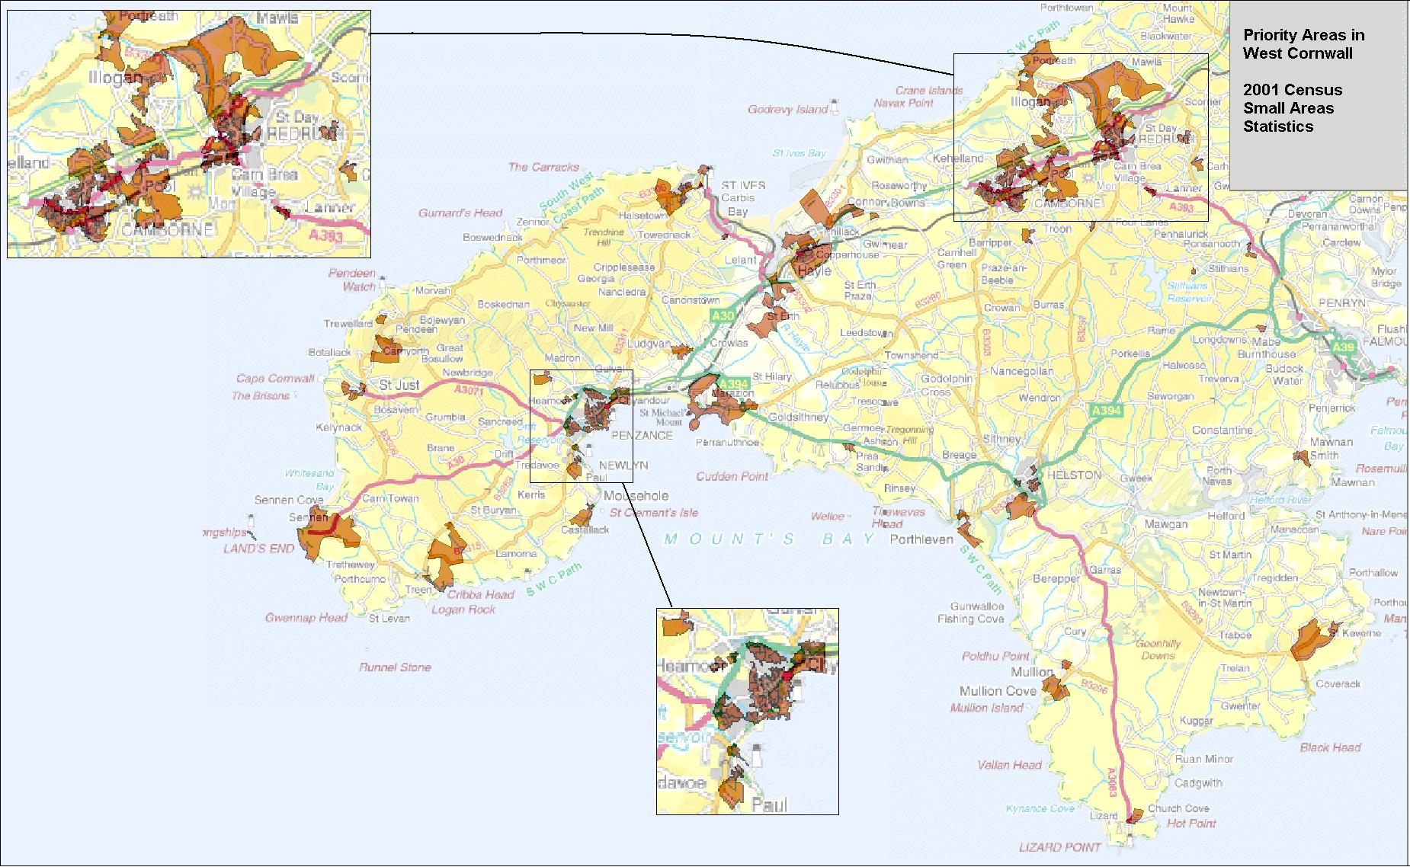

Table 8: Final Index: Most Deprived 20 Output Areas, 2001 Census

Rank | Final Index | Output Area | Ward Name | Area
1 | 6.6 | 15UFGD0009 | Penzance Central | St Clare Street
2 | 11.1 | 15UFGE0020 | Penzance East | Parc Mellan, Polweath
3 | 20.8 | 15UFGG0018 | Penzance South | Chywoone Crescent
4 | 26.4 | 15UDGC0013 | Camborne West | Wellington Close / Uglow Close
5 | 28.0 | 15UDGB0019 | Camborne South | Grenville Gardens
6 | 28.1 | 15UDGH0006 | Illogan North | Churchtown
7 | 31.5 | 15UDGP0019 | Redruth North | Murdoch Close
8 | 31.9 | 15UFGK0007 | St. Ives North | Trelawney Avenue
9 | 34.4 | 15UFGC0015 | Morvah Pendeen and St. Just | Lower Boscaswell
10 | 35.7 | 15UDGP0021 | Redruth North | Close Hill / Edmund Hill
11 | 38.1 | 15UFGE0019 | Penzance East | Collinsey Road, Treweath Road
12 | 40.3 | 15UFGG0015 | Penzance South | Gwavas Lane, Gwavas Estate, Treveneth Crescent
13 | 41.1 | 15UDGB0010 | Camborne South | Pengegon - Gwelmor / Meneth Rd / Penforth
14 | 45.6 | 15UDGJ0014 | Illogan South | Illogan Highway - East Pool Park / Chywoon Gardens
15 | 50.0 | 15UDGB0006 | Camborne South | Pengegon Parc
16 | 53.0 | 15UDGC0017 | Camborne West | Coronation Avenue
17 | 55.9 | 15UDGC0007 | Camborne West | St Martins Terrace / Weeth Rd (East)
18 | 57.6 | 15UDGB0009 | Camborne South | Pengegon - Foundry Road / Stray Park Way
19 | 58.7 | 15UFGK0002 | St. Ives North | Penbeagle, Industrial Estate
20 | 58.9 | 15UFFU0014 | Gwinear Gwithian and Hayle East | Loggans Moor

The priority areas identified by both the 1991 and 2001 Census analyses (Figures 1 and 20) are mainly concentrated in the Camborne, Pool, Redruth area, Penzance area, St Ives area, Hayle area, Newlyn area, Helston area, St Just area, Porthleven area, Hayle & Towans, Troon area and Pendeen areas.

However, the technical advances now available, particularly the development of the OA geography, has allowed the identification of much smaller pockets of deprivation and need in the more rural areas of West Cornwall than was previously possible. For example, Carharrack, Lanner, Ponsanooth, Stithians, Four Lanes, Mabe Burnthouse, Mawnan Smith, the Lizard, Ludgvan and Germoe are identifiable as areas containing pockets of considerable deprivation in 2001 (Figure 20). These more rural areas were not identifiable as having a priority level of need using the 1991 Census data (Figure 1).

The 1991 Census EDs had only limited social meaning as they were designed primarily to equalise as far as possible the workloads of enumerators. By contrast, the 2001 Census OAs are much more socially homogeneous and meaningful as they group together houses and flats by both tenure and dwelling type (eg 1930s owner occupied terraced houses, 1960s semi-detached council houses, etc.). Since, in many parts of the UK, the population is stratified by the housing market – rich people tend to live in expensive houses and poor people live in lower value accommodation – the 2001 OA geography is superior to the 1991 ED geography for identifying multiply deprived areas. Thus, the new 2001 priority areas identified can be considered to be a more sharply focused version of the 1991 estimates allowing the areas of greatest need in West Cornwall to be more precisely identified. Figures 20 and 21 clearly show this effect – the 1991 Priority areas based on the ED geography are more broad and diffuse than the new areas of priority need identified in this analysis based on the 2001 OA geography and the improved measures of deprivation.

Conclusion
This analysis of the 2001 Census data has highlighted both the significant improvements in the availability and quality of data for measuring poverty and deprivation in West Cornwall as well as a number of technical challenges which needed to be surmounted.

A more accurate and precise analyses of priority need is now possible than was achievable using 1991 Census data. In particular, smaller pockets of deprivation in the more rural areas of West Cornwall are now identifiable as having a priority level of need. The conclusion of this research is that the West Cornwall Local Strategic Partnership may wish to consider extending the priority areas eligible for NRF funding to include Carharrack, Lanner, Ponsanooth, Stithians, Four Lanes, Mabe Burnthouse, Mawnan Smith, Ludgvan and Germoe as all these areas can now be shown to have a priority level of need based upon ‘objective’ scientific criteria.

References

Booth, C. (1893) Life and Labour of the People in London: first results of an inquiry based on the 1891 Census. Journal of the Royal Statistical Society, Vol LIV, Pt IV, 600-643
Bruce, A., Gordon, D. and Kessell, J. (1995a) Analysing Rural Poverty. Local Government Policy Making. 22(1): 16-23.
Bruce, A., Gordon, D. and Kessell, J. (1995b) The Undeveloped Country. Local Government Chronicle, 7 July, 14.
Burrows, R. and Rhodes, D. (1998) Unpopular places? Area disadvantage and the geography of misery in England. Bristol: The Policy Press.
Cemlyn, S., Fahmy, E., Gordon, D. and Bennett, S. (2002). Poverty and Neighbourhood Renewal in West Cornwall. Research Report for West Cornwall Local Strategic Partnership. [Available at: www.bris.ac.uk/poverty/region.htm].
Cemlyn, S., Fahmy, E. and Gordon, D. (2004, accepted for publication) Poverty, Neighbourhood Renewal and the Voluntary Sector in West Cornwall. Community Development Journal.
Clark, A. and Thomas, F. (1990) The geography of the 1991 Census. Population Trends 60: 9-15.
DWP (2003) Measuring Child Poverty consultation: Final Conclusions. London, Department for Work and Pensions.
http://www.dwp.gov.uk/consultations/consult/2003/childpov/final.asp
Glennerster, H., Lupton, R., Noden, P. and Power, A. (1999) Poverty, Social Exclusion and Neighbourhood: Studying the area bases of social exclusion CASE Paper 22, LSE.
Gordon, D. (1995) Census based deprivation indices: their weighting and validation, Journal of Epidemiology and Community Health, 49 (Suppl 2)
Gordon, D. and Forrest, R. (1995) People and Places Volume II: Social and Economic Distinctions in England – A 1991 Census Atlas, Bristol: SAUS and the Statistical Monitoring Unit.
Gordon, D. and Loughran, F. (1997) Child Poverty and Needs Based Budget Allocation, Research, Policy and Planning 15(3): 28-38.
Gordon, D. and Pantazis, C. (Eds) (1997) Breadline Britain in the 1990s. Aldershot: Ashgate.
Gordon, D., Adelman, A., Ashworth, K., Bradshaw, J., Levitas, R., Middleton, S., Pantazis, C., Patsios, D., Payne, S., Townsend, P. and Williams, J. (2000) Poverty and social exclusion in Britain. York: Joseph Rowntree Foundation.
Gordon, D. and Townsend, P. (Eds) (2000) Breadline Europe: The measurement of poverty. Bristol: Policy Press.
McKay, S. and Collard, S. (2004) Developing Deprivation Questions for the Family Resources Survey. IAD Research Division Working Paper Number 13, London, Department for Work and Pensions.
http://www.dwp.gov.uk/asd/asd5/WP13.pdf
Mack, J. and Lansley, S. (1985) Poor Britain, London: Allen and Unwin.
Martin, D., Nolan, A. and Tranmer, M. (2001) The application of zone-design methodology in the 2001 UK Census. Environment and Planning A, 33, pp1949 -1962.
Martin, D. (2002) Geography for the 2001 Census in England and Wales, Population Trends 108: 7-15
Moss, C. (1999) Selection of topics and development of questions for the 2001 Census. Population Trends, 97.
ONS (2000a) Census 2001 – What’s New? Census 2001 Factsheet 3, Titchfield, Office for National Statistics.
ONS (2000b) The Census Questions. Census 2001 Factsheet 9, Titchfield, Office for National Statistics.
Openshaw, S. (1977) A geographical solution to scale and aggregation problems in region-building, partitioning and spatial modelling Transactions of the Institute of British Geographers NS 2, 459-72.
Payne, S., Henson, B., Gordon, D. and Forrest, R. (1996) Poverty and Deprivation in West Cornwall in the 1990s. A Report to the West Cornwall Initiative. Bristol: Statistical Monitoring Unit.
Saunders, J. (1998) Weighted Census-based deprivation indices: their use in small areas. Journal of Public Health Medicine 20(3): 253-260.
Townsend, P. (1979) Poverty in the United Kingdom. London: Penguin.
Wathan, J., Holdsworth, C., and Leeser, R. (2004) Alternative household classifications for the 2001 Census. Environment and Planning A, 36(6): 1101-1123.

Appendix: Priority Areas 2001

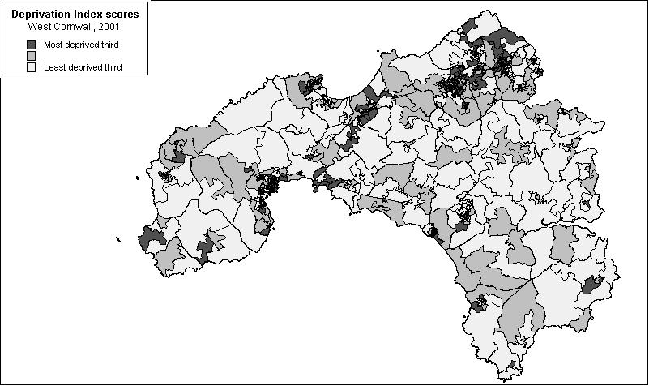

Note: available crime data are currently not sufficiently reliable to identify the small areas with the highest crime rates with any degree of certainty – see Cemlyn et al (2002) for discussion.
On 17 June 2004, revised tables were released for the Living Environment and Crime domains of the 2004 IMD http://www.odpm.gov.uk/pns/DisplayPN.cgi?pn_id=2004_0141 but further revisions may be necessary given the mistakes which have recently been reported with the 2001 Census Living Environment and Crime Area Statistics data.
http://www.devon-cornwall.police.uk/wclsp/fund/nrstrat/RenewalStrategy.pdf
http://www.statistics.gov.uk/census2001/outputclassifications.asp
http://www.statistics.gov.uk/census2001/outputclassifications.asp
In the Breadline Britain in the 1990s survey, poverty was defined scientifically using the consensual method e.g. in order to be poor a household had to have both a low income and a standard of living that was below the minimum acceptable to the majority of the British population.
This survey used a similar consensual method to measure poverty as the 1990 Breadline Britain Survey.
We would like to thank Matthew Brown and Kathryn Meredith for providing these brief OA location descriptions and names.
The level is fixed as equal to our relative low-income threshold for the baseline year of 1998/99 expressed in today’s prices. A child in this example is aged under 14 years. As incomes are adjusted for family size, the actual cash threshold will be lower for small lone parent families and higher for larger families. Income is being measured before housing costs and will therefore include any Housing Benefit a family receives. (DWP, 2003)

